Course Code: COMP9900

Course Title: Information Technology Project

Group Name: 9900-F18P-theFuture

Group Members

|  |  |  |  |
| --- | --- | --- | --- |
| Name | Email | Student ID | Role |
| Mingxuan Chen | mingxuan.chen@student.unsw.edu.au | z5330738 | Developer |
| Mohanteja Dharmavarapu | m.dharmavarapu@student.unsw.edu.au | z5242057 | Developer |
| Kamiyu Hijikata | k.hijikata@student.unsw.edu.au | z5353288 | Scrum master & Developer |
| Simon Keung | s.keung@student.unsw.edu.au | z3292483 | Developer |
| Tianchen Lan | tianchen.lan@unsw.edu.au | z5114773 | Developer |

Proposal Submission Date: 3 October 2022

Contents

Contents 2

Background 3

Problem Statement 3

Introduction 3

Why are recipes important? 3

Online Options 3

Traditional Options 3

Proposed Solution 4

Deep Dive of Existing Websites 4

Kitchen Stories 4

Allrecipes 4

User Stories 5

User Stories defined in JIRA 5

Novel Functionality 1: Support contributors by tipping 8

Novel Functionality 2: Recipe price estimate 8

Sprints 9

Sprint 1 – Setup in JIRA 9

Sprint 2 & 3 9

Interface and flow diagrams 10

System Architecture 12

Overview 12

Frontend 13

Backend 13

Choice of Architecture 13

References 15

# Background

## Problem Statement

### Introduction

The proliferation of the world wide web has caused massive growth in sharing and collaboration in practically any domain, and this has been especially so when it comes to the world of cooking. Recipes, traditionally written down and passed along from generation to generation, are now easily accessible on the web for almost any cuisine from all corners of the globe. The ease of access has widened the culinary palettes of college students living alone for the first time and professional chefs alike.

### Why are recipes important?

Recipes enable people to learn to cook a particular dish. Fundamentally, a recipe is a list of ingredients (with measurements) and a method of cooking a dish. Following the method, which is an ordered set of cooking procedures to apply to the ingredients, in a precise way allows recreation of a dish. People may utilize a recipe exactly or may adapt a recipe with modifications based on their own cooking knowledge and experience, which could result in developments of new recipes. Therefore, recipes are an important part of cooking, and an effective way to find, obtain, and share recipes is important.

### Online Options

There are numerous avenues which provide access to these recipes online; perhaps the most commonly used are websites that consist of user contributed recipes that are accessible as a database of information, such as Allrecipes and Kitchen Stories. While these provide vast amounts of knowledge, they provide little interaction between users beyond basic likes and comments. Other websites include those where the website creator/owner is also the sole content creator, such as Sally’s Baking Addiction (Sally's Baking Addiction, 2022). These often more social interaction from the poster by the way of more personal, blog-style recipe posts, but lack meaningful social interaction from the user end, and also lack the depth of information available on user-contributed sites. Finally, there also exists a multitude of forum-style websites such as Cooking Bites (CookingBites Cooking Forum, 2022) and Discuss Cooking (Discuss Cooking - Cooking Forums, 2022), as well as cooking-focused communities on content aggregation sites such as Reddit, where social interaction is aplenty. Unfortunately, their free flowing and less structured information makes it more difficult to ascertain information in a convenient manner, and often lacks an effective search function to retrieve older information.

### Traditional Options

Historically, recipes were shared informally between family and friends. Some recipes were even considered a family secret, handed down generations!

Alternatively, recipes could also be published into cookbooks by chefs or other prominent authors.

There are some limitations with these ways of sharing recipes.

There are many everyday people, for various reasons, such as wanting to share their culture or to contribute to development of cuisine, who would enjoy easily sharing their recipes broadly for others to use. For consumers of recipes, obtaining such recipes has requires having family or friends who know these recipes, or otherwise having to purchase or acquire these cookbooks.

Sharing between family and friends only has a limited audience, while publishing a book has requirements that exceed the investment of the everyday person. Clearly, a better solution is desired that enable easy and accessible sharing and accessing of recipes compared to some of these traditional options.

### Proposed Solution

Our group will help solve this problem by providing a new online website for Contributors to share their recipes. Everyday people can become a Contributor to casually write and publish recipes that allows Explorers to discover and find new recipes.

We will provide better search and discovery tools.

Not only that, there is also a social element, where users can comment and like recipes, allowing Contributors to easily obtain feedback and further refine their recipes. Users can subscribe to Contributors they like to follow their new recipe releases they like, while contributors can grow their subscriber base which encourages them to make more contributions.

Furthermore, our website is the future of recipe websites, as we have two novel functionalities, being tipping and recipe price estimate which make our website more useful than other existing recipe websites.

## Deep Dive of Existing Websites

As discussed, there are already existing user contributed websites. As our proposed website is considered in the same category, we have conducted a deep dive and found drawbacks with those websites which will be considered when developing our website.

### Kitchen Stories

Kitchen Stories (<https://www.kitchenstories.com>) is a “cross-media cooking platform, available as an app, website, on smart TVs or via Amazon Echo Show. In addition to getting free recipes for every occasion, HD video tutorials and inspiring articles, users can also upload their own culinary creations to the platform and share them with the global community…. [their] mission is to empower people to cook a fresh meal every day.” (Kitchen Stories, 2022).

Similar to our proposal, Kitchen Stories allow user contributed recipes to encourage people to cook. Ours investigation has uncovered these drawbacks:

* Cannot subscribe to Contributors and receive a news feed based on subscription to Contributors
* Cannot get list of recommended recipes based on ingredients the Explorer possesses
* Can only filter by category of main ingredient, not specific ingredients, or combination of ingredients
* Cannot explore recipes by method.

### Allrecipes

Allrecipes (<https://www.allrecipes.com/>) is a “community built by and for kitchen experts…Allrecipes connects home cooks with their greatest sources of inspiration — other home cooks)” (Allrecipies, 2022). Similar to our proposal, Allrecipes allow user contributed websites to encourage people to cook recipes. Ours investigation has uncovered these drawbacks:

* Cannot comment on recipe without reviewing.
* Recipe recommendation just shows popular recipes in the same category rather than recipe similarity based on ingredients.
* Cannot filter recipes by more than one categorization at the same time (e.g., ingredients and category).
* Cannot explore recipes by method.

# User Stories

### User Stories defined in JIRA

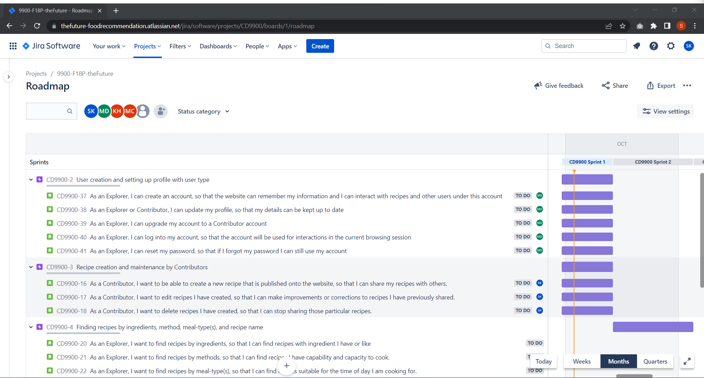

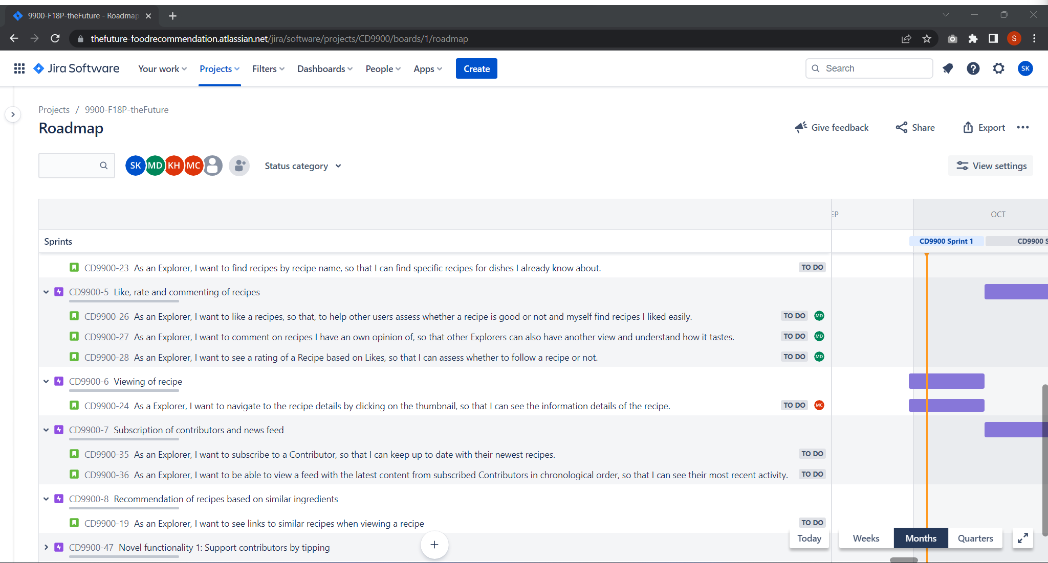

|  |  |  |
| --- | --- | --- |
| **Project Objectives (from Specification)** | **User Stories** | **Explanation** |
| Contributors must be able to create and maintain a profile for  themselves, which includes their username, contact details (email address), and a list of recipes that this contributor has published. | 37,38,39,40,41 | The user stories allow people to create an account, which is universal to Explorers and Contributors, however by adding all required information (profile photo), they can start to contribute recipes. Their list of recipes are covered by the user stories below. |
| The system/platform must allow contributors to maintain a set of their own recipes that explorers can look through, with each recipe requiring a name, ingredients, method, meal-type(s) (breakfast, lunch, dinner, …), and a photo. | 16,17,18 | The user stories allow Contributors to create, edit, and delete recipes that can then be seen by Explorers. Recipes must contain all requisite information to be submitted. |
| Explorers must also be able to convey their opinion for any recipe by  either liking and/or commenting on it. | 26,27,28 | The user stories allow Explorers to like and comment on a particular recipe. The Explorer must be logged in.  The social engagement is also used for ranking purposes. |
| The system/platform must also provide explorers with the ability to find recipes they are interested in based on any combination of the following: ingredients, method, meal-type(s), and recipe name. The resulting list should show a summary that includes the name and a photo thumbnail for each recipe. | 20,21,22,23 | The user stories allow finding of recipes by combination of ingredients, method, meal-type(s). We will have various checkboxes to allow selection, and a textbox for recipe name as search. In the search screen we show a card for each recipe result. |
| Explorers must be able to navigate to the recipe details by clicking on the thumbnail. Details include: the recipe name, ingredients, method, meal type(s), a photo for the recipe, the number of likes for the recipe, and recipe comments. | 24 | The user stories allow viewing of recipes after clicking on the card, showing the required detail. |
| Explorers must also be able to subscribe/unsubscribe to any contributors on the platform/system. When an explorer is subscribed to a given contributor, they should be able to see, in their personal recipe news feed, new recipes that are added or have been recently updated by that contributor.  A given explorer's personal recipe news feed must be sorted based on the recipe creation/update date (most recent to oldest) then by the total number of likes that this explorer has for the recipe's contributor profile (highest to lowest count). | 35, 36 | The user stories allow subscribing and unsubscribing the contributors, which appear in a logged in Explorers front page news feed. |
| The system/platform must provide recommendations for recipes that are similar to a given reference recipe based on that reference recipe's ingredients, with recommendations to be ordered based on how close each result is to the reference recipe's ingredients. Design a metric to represent closeness between two sets of ingredients, and sort results from closest match to reference recipe’s ingredients to furthest match. Exclude any recipes from results that have no ingredients in common to the reference recipe. | 19 | The user stories allow after clicking into a recipe, we will show up to 5 similar recipes based on recipe ingredient closeness. Our metric will also consider the total frequency of ingredients, for example, salt is a common ingredient, hence less weight should be placed if it is in common with other recipes. |

### Novel Functionality 1: Support contributors by tipping

As per our research, there are already many websites that offer recipes for free that most people would not expect to be required to pay for them. Like many other information resources, it cannot be dismissed that recipes take time and effort for contributors to write up and prepare. Recipes are not created without investment in ingredients and time to test and experiment. Thus, we want to provide a feature that allow Explorers to support contributors for their contributions, by allowing Explorers to make micropayments towards the contributors, it will give Contributors ‘kudos’ and encourage them to continue to develop and share better recipes. Explorers that tip will be recognised on the Contributor’s public profile page to provide a social reward towards tipping.

Rewarding of content creators is not a new concept. For example, Twitter has a Tip Jar feature (Twitter, 2022) that lets you tip people whose tweets you like; YouTube has a Super Thanks (Google, 2022) program allowing viewers to tip creators they like. However, the application of tipping to recipes is novel, our internet search of this has not found any result, and we believe this is an important niche to fill.

From a technical perspective, this will require (realistic simulation of) payments processing.

### Novel Functionality 2: Recipe price estimate

There are many factors in which people choose to cook a particular dish. While difficulty and culinary preferences are obvious reasons, across the world, people also consider the cost of ingredients. In the United States, the lowest income quintile of households spent 27% of their income on food in 2020 (U.S. Department of Agriculture, 2022). So, there is demand for users to be able to find budget conscious recipes and reduce their household expenditure.

Some recipe websites have a ‘budget conscious’ category or similar. However, these inevitably require the contributor to tag the recipe as such. Our novel functionality will estimate the price of recipes based on data. This means the recipe price estimate will be much more accurate and have a greater level of granularity. The price estimate can also update based on what’s already in the fridge.

From a technical perspective, this will require sourcing of data and application of this data to perform the estimate.

As prices of ingredients can vary in different localities, in our current release we will only provide prices estimates for one geographic locality, with the ability to extend it to different localities.

# Sprints

## Sprint 1 – Setup in JIRA

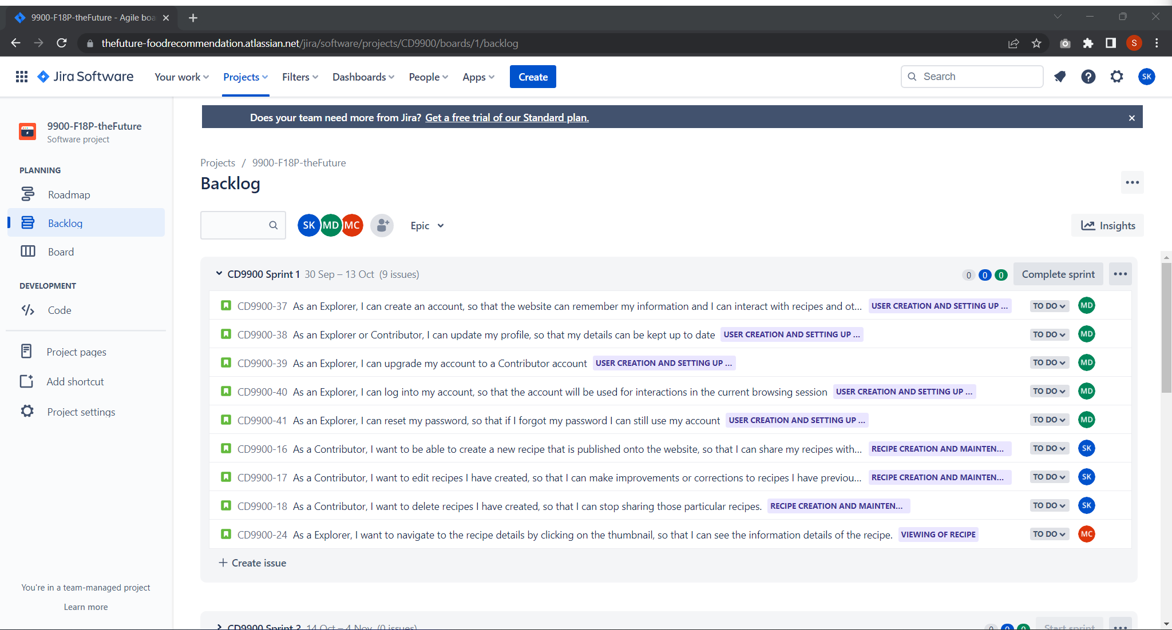

Sprint 1 is from 30 September 2022 to 13 October 2022 and consists of all user stories in the following Epics: User creation and setting up profile with user type, Recipe creation and maintenance by Contributors, Viewing of recipes

## Sprint 2 & 3

Sprint 2 is planned for 14 October 2022 – 4 November 2022.

Sprint 3 is planned for 5 November 2022 – 19 November 2022.

# Interface and flow diagrams

%3CmxGraphModel%3E%3Croot%3E%3CmxCell%20id%3D%220%22%2F%3E%3CmxCell%20id%3D%221%22%20parent%3D%220%22%2F%3E%3CmxCell%20id%3D%222%22%20value%3D%22TIP%22%20style%3D%22ellipse%3BwhiteSpace%3Dwrap%3Bhtml%3D1%3BstrokeWidth%3D2%3BfontSize%3D11%3BfillColor%3D%23dae8fc%3BstrokeColor%3D%236c8ebf%3B%22%20vertex%3D%221%22%20parent%3D%221%22%3E%3CmxGeometry%20x%3D%22699.38%22%20y%3D%22731%22%20width%3D%2280%22%20height%3D%2230%22%20as%3D%22geometry%22%2F%3E%3C%2FmxCell%3E%3C%2Froot%3E%3C%2FmxGraphModel%3E

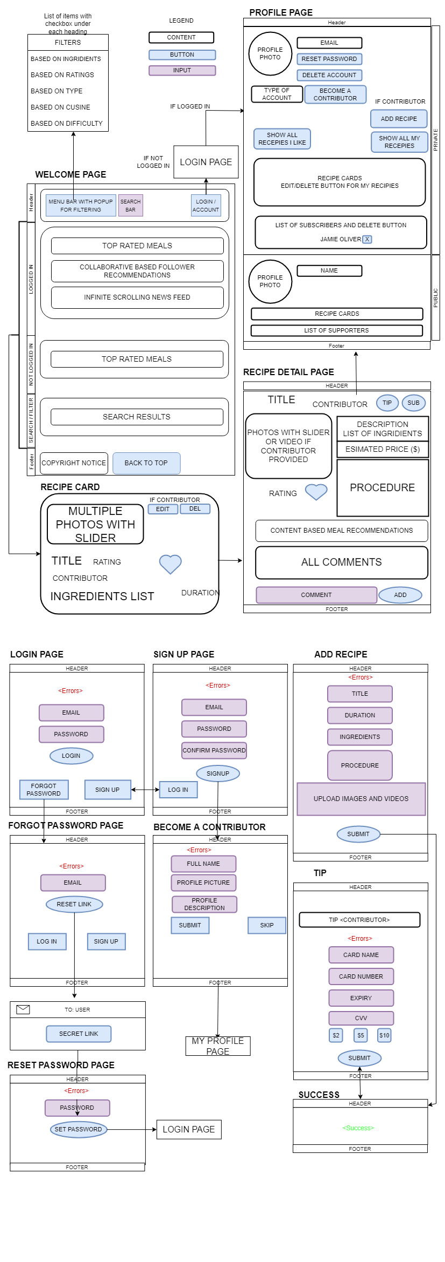

Users start at the Welcome page, the Welcome page shows various cards based on whether you are logged in or not. If you are logged in, the cards will be more personalised including showing your news feed. Once you use the search options at the top, where you can select multipe chceckboxes across the categories, and enter search terms in the search box, it will start filtering the recipe cards. The recipe cards show a summary of each recipe, clicking into it shows the detail including photo, ingrdients, estimated price, method and comments etc. Explorers can also add a comment, click the buttons to, tip Contributors and subscribe to them. Clicking the link to the Contributor lets you view their public profile where you see cards of their recippies and their supporers (people who have tipped). Clicking the link on the top right corner takes you to your personal profile (in logged in) where you can update your personal settings, your subscribers, and manage your contributions (if you are a contributor). If you are not logged in , you will go through the login flow below.

The login flow is typical, users can login to your account by email and password, if the user forgot their details, they can request a password link to reset it, if they don’t have an account they can enter minimal details to create an account. One difference from typical login flow is there is an optional step, if they enter those optional details, they will unlock extra features to become a Contributor, otherwise they can skip the step and enter it later.

The adding/edit a recipe screen is arrived from the Contributor’s personal profile. Here we simply have several input fields and an image upload function which the Contributor must populate to add/edit a recipe. Once submission is successful, they will receive a success confirmation message and detail.

The tipping screen is arrived from the Contributor’s public profile. Here, we take the Explorer’s payment details, their tipping amount, and allow them to submit it. Once successful payment is taken, they will receive a success confirmation message and detail.

# System Architecture

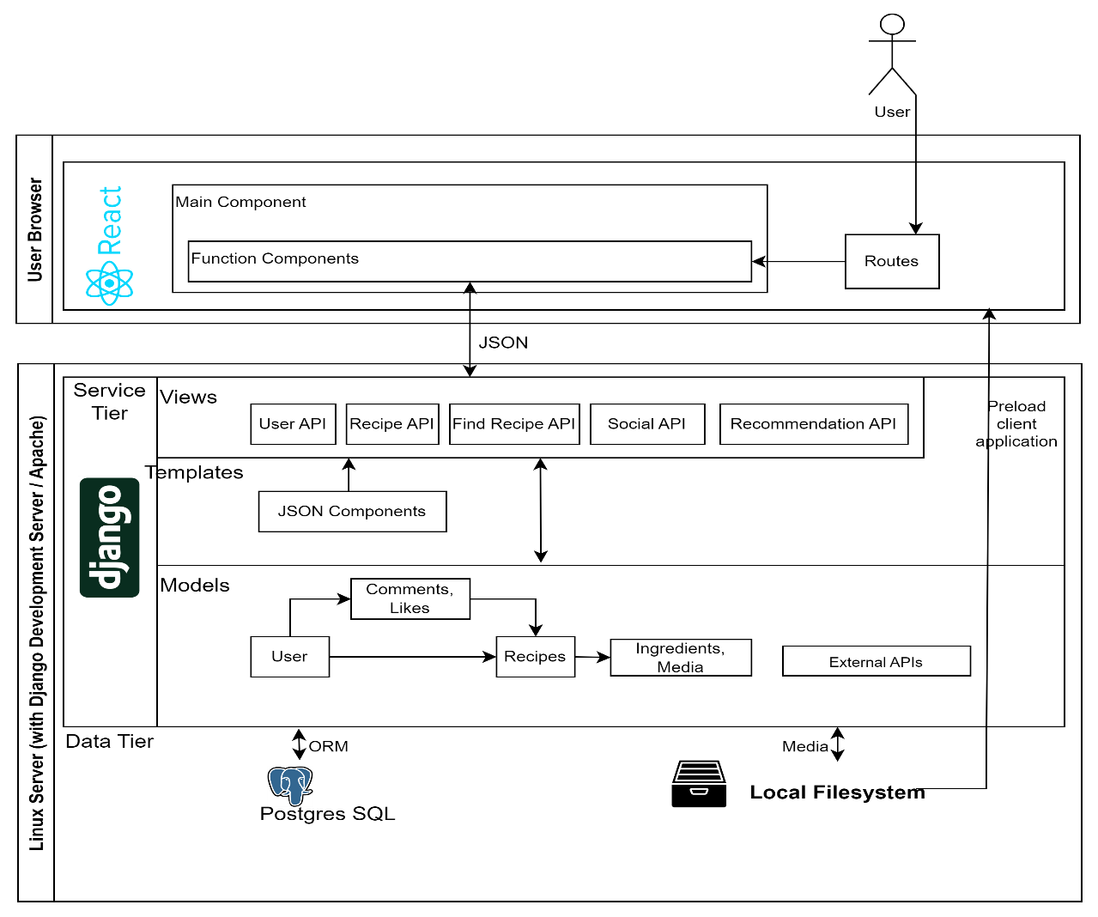

## Overview

The overall architecture can be succinctly summarized as a client single page application front end, a service layer consisting of a thin backend application, and a data layer consisting of a relational database and file storage. The web application and static assets are served to the client through either a Django development grade or Apache web server.

## Frontend

The frontend is a React application written in JavaScript, HTML and CSS.

Upon the user first accessing of the website, all HTML, JavaScript, and CSS assets will be served to the user and loaded in the initial HTTP request from the web server.

The React application consists of a main component which handles global features such as presenting the header/footer content and authentication.

The feature components can be accessed by different address paths, which are managed by the routing library which map requests to various paths to various components. The various feature components provide specific features to the web application.

Subsequent interactions with the application will not result in a page load, rather the client application will use preloaded assets and make asynchronous requests to various APIs in the backend.

## Backend

The backend is a Python application written using the Django framework. The backend application provides various web services to be consumed by the front end.

The Django framework uses a Model-View-Template architecture which is similar to the more common Model-View-Controller architecture (Django Software Foundation, 2022); the Model provides class objects, the View is similar to the Controller in MVC is the glue between the Model and Templates, and finally, the View renders the Templates which describe the format of the data responses.

The Model is mapped to a PostgreSQL database through the Django Object Relational Mapper. Storage of multimedia and binary data is in the file system rather than the relational database.

## Choice of Architecture

We have chosen system components that have some relatively established and suited to our purpose. We also narrowed down our choice based on familiarity within our group, the importance of which cannot be understated compared to technical reasons for decisions, given the short time frame to deliver this project.

React – There are various JavaScript front end frameworks. Compared to native JavaScript, the React framework enables the application to be made up of Components which bind HTML against JavaScript variables, which improves code organisation and makes the application code more concise.

In comparison with other frameworks, React is currently the most popular front-end JavaScript framework (Stack Overflow, 2022), which suggestions there is a great supporting ecosystem.

Django – The benefit of Django is that out of the box, CRUD web applications can be built relatively quickly. There is in-built ORM, which means the developers only need to define the models, and it will automatically manage persistence of the models in the database. Using scaffolding tools, various APIs can be autogenerated for the models with little effort and will only need minor customisation. It is also the most popular Python framework (Stack Overflow, 2022), which means there is a great supporting community.

There are disadvantages with Django, the main one is probably the same one that makes Django suitable to rapid development, is that a lot comes out of the box, it is more rigid and monolithic, there is less flexibility to deviate from some of the technical choices it has made. However, our application requirement fits within the realm of common web applications, we do not see a need to deviate from it.

PostgreSQL – We have chosen this database as it is a common relational SQL database system. Overall, we are limited to one of the database systems Django support, PostgreSQL is one of the 5 that it supports (Django Software Foundation, 2022).

Relational database systems are less suited towards storing of large files. For this, we are using the file system instead. We rule out SQLLite as the document suggests it is for applications that are “predominately read-only” (Django Software Foundation, 2022). We also rule out Oracle as it requires a commercial license). Finally, the documentation further states that “PostgreSQL is the most capable of all the databases… in terms of schema support” (Django Software Foundation, 2022). To minimise friction, we follow this recommendation in absence of other reasons.

Web Server – For development and demonstrative purposes the built in Django web server can easily launch a web server with minimal installation and configuration which makes it suitable for anyone to load the application.

However, for production purposes, the application can be deployed on Apache, being a production grade web server, it has more features such as security, scalability, and networking in mind.

# References

Allrecipies, 2022. *About Allrecipies.* [Online]   
Available at: https://www.allrecipes.com/about-us-6648102  
[Accessed 03 October 2022].

CookingBites Cooking Forum, 2022. *CookingBites Cooking Forum.* [Online]   
Available at: https://www.cookingbites.com/  
[Accessed 03 October 2022].

Discuss Cooking - Cooking Forums, 2022. *Discuss Cooking - Cooking Forums.* [Online]   
Available at: https://www.discusscooking.com/  
[Accessed 03 October 2022].

Django Software Foundation, 2022. *Databases.* [Online]   
Available at: https://docs.djangoproject.com/en/4.1/ref/databases/  
[Accessed 03 October 2022].

Django Software Foundation, 2022. *FAQ: General.* [Online]   
Available at: https://docs.djangoproject.com/en/4.1/faq/general/#django-appears-to-be-a-mvc-framework-but-you-call-the-controller-the-view-and-the-view-the-template-how-come-you-don-t-use-the-standard-names  
[Accessed 03 October 2022].

Django Software Foundation, 2022. *Migrations.* [Online]   
Available at: https://docs.djangoproject.com/en/dev/topics/migrations/#backend-support  
[Accessed 03 October 2022].

Google, 2022. *Turn on and manage Super Thanks.* [Online]   
Available at: https://support.google.com/youtube/answer/10878910?hl=en  
[Accessed 03 October 2022].

Kitchen Stories, 2022. *About.* [Online]   
Available at: https://pages.kitchenstories.com/en/about  
[Accessed 03 October 2022].

Sally's Baking Addiction, 2022. *Trusted Recipes from a Self-Taught Baker.* [Online]   
Available at: https://sallysbakingaddiction.com/  
[Accessed 03 October 2022].

Stack Overflow, 2022. *Stack Overflow.* [Online]   
Available at: https://survey.stackoverflow.co/2022/#most-popular-technologies-language  
[Accessed 03 October 2022].

Twitter, 2022. *About tips and tipping.* [Online]   
Available at: https://help.twitter.com/en/using-twitter/tips  
[Accessed 03 October 2022].

U.S. Department of Agriculture, 2022. *Food spending as a share of income declines as income rises.* [Online]   
Available at: https://www.ers.usda.gov/data-products/chart-gallery/gallery/chart-detail/?chartId=58372  
[Accessed 03 October 2022].